**ASSIGNMENTS MODULE 1**

**MODULE: 1 (SDLC)**

1. What is software? What is software engineering?

2.Explain types of software

3.What is SDLC? Explain each phase of SDLC

4.What is DFD? Create a DFD diagram on Flipkart

5.What is Flow chart? Create a flowchart to make addition of two numbers

6.What is Use case Diagram? Create a use-case on bill payment on paytm

**ANSWERS**

ANS 1.-Software is a program or set of programs containing instructions that provide desired functionality. And Engineering is the process of designing and building something that serves a particular purpose and finds a cost-effective solution to problems.

Software engineering is the process of designing, developing, testing, and maintaining software. It is a systematic and disciplined approach to software development that aims to create high-quality, reliable, and maintainable software. Software engineering includes a variety of techniques, tools, and methodologies, including requirements analysis, design, testing, and maintenance.

ANS 2 - The two main categories of software are application software and system software.

An application is software that fulfills a specific need or performs tasks.

System software is designed to run a computer's hardware and provides a platform for applications to run on top of.

ANS 3 -**SDLC (Software Development Life Cycle)** is used in Every Software Development Company because it is the root of the Development Cycle, if that model would not exist in the world, firstly no software can build secondly if any how it would be made, it’s not going to succeed it has no use, because of no maintenance, but Luckily SDLC model exist in Tech world **But why we need it Actually!**

There are several reasons why organizations use the Software Development Life Cycle (SDLC) when developing software applications:

To provide a **structured and organized approach**to software development: The SDLC provides a framework for managing the software development process, which helps to ensure that all necessary steps are taken and that the final product meets the requirements.

%3CmxGraphModel%3E%3Croot%3E%3CmxCell%20id%3D%220%22%2F%3E%3CmxCell%20id%3D%221%22%20parent%3D%220%22%2F%3E%3CmxCell%20id%3D%222%22%20value%3D%22%22%20style%3D%22edgeStyle%3DorthogonalEdgeStyle%3Brounded%3D0%3BorthogonalLoop%3D1%3BjettySize%3Dauto%3Bhtml%3D1%3B%22%20edge%3D%221%22%20source%3D%223%22%20target%3D%225%22%20parent%3D%221%22%3E%3CmxGeometry%20relative%3D%221%22%20as%3D%22geometry%22%2F%3E%3C%2FmxCell%3E%3CmxCell%20id%3D%223%22%20value%3D%22REQUIREMENTS%22%20style%3D%22rounded%3D1%3BwhiteSpace%3Dwrap%3Bhtml%3D1%3B%22%20vertex%3D%221%22%20parent%3D%221%22%3E%3CmxGeometry%20x%3D%22340%22%20y%3D%2280%22%20width%3D%22120%22%20height%3D%2260%22%20as%3D%22geometry%22%2F%3E%3C%2FmxCell%3E%3CmxCell%20id%3D%224%22%20value%3D%22%22%20style%3D%22edgeStyle%3DorthogonalEdgeStyle%3Brounded%3D0%3BorthogonalLoop%3D1%3BjettySize%3Dauto%3Bhtml%3D1%3B%22%20edge%3D%221%22%20source%3D%225%22%20target%3D%227%22%20parent%3D%221%22%3E%3CmxGeometry%20relative%3D%221%22%20as%3D%22geometry%22%2F%3E%3C%2FmxCell%3E%3CmxCell%20id%3D%225%22%20value%3D%22ANALYSIS%22%20style%3D%22rounded%3D1%3BwhiteSpace%3Dwrap%3Bhtml%3D1%3B%22%20vertex%3D%221%22%20parent%3D%221%22%3E%3CmxGeometry%20x%3D%22340%22%20y%3D%22180%22%20width%3D%22120%22%20height%3D%2260%22%20as%3D%22geometry%22%2F%3E%3C%2FmxCell%3E%3CmxCell%20id%3D%226%22%20value%3D%22%22%20style%3D%22edgeStyle%3DorthogonalEdgeStyle%3Brounded%3D0%3BorthogonalLoop%3D1%3BjettySize%3Dauto%3Bhtml%3D1%3B%22%20edge%3D%221%22%20source%3D%227%22%20target%3D%229%22%20parent%3D%221%22%3E%3CmxGeometry%20relative%3D%221%22%20as%3D%22geometry%22%2F%3E%3C%2FmxCell%3E%3CmxCell%20id%3D%227%22%20value%3D%22DESIGN%22%20style%3D%22rounded%3D1%3BwhiteSpace%3Dwrap%3Bhtml%3D1%3B%22%20vertex%3D%221%22%20parent%3D%221%22%3E%3CmxGeometry%20x%3D%22340%22%20y%3D%22280%22%20width%3D%22120%22%20height%3D%2260%22%20as%3D%22geometry%22%2F%3E%3C%2FmxCell%3E%3CmxCell%20id%3D%228%22%20value%3D%22%22%20style%3D%22edgeStyle%3DorthogonalEdgeStyle%3Brounded%3D0%3BorthogonalLoop%3D1%3BjettySize%3Dauto%3Bhtml%3D1%3B%22%20edge%3D%221%22%20source%3D%229%22%20target%3D%2211%22%20parent%3D%221%22%3E%3CmxGeometry%20relative%3D%221%22%20as%3D%22geometry%22%2F%3E%3C%2FmxCell%3E%3CmxCell%20id%3D%229%22%20value%3D%22IMPLIMENTATION%22%20style%3D%22rounded%3D1%3BwhiteSpace%3Dwrap%3Bhtml%3D1%3B%22%20vertex%3D%221%22%20parent%3D%221%22%3E%3CmxGeometry%20x%3D%22340%22%20y%3D%22380%22%20width%3D%22120%22%20height%3D%2260%22%20as%3D%22geometry%22%2F%3E%3C%2FmxCell%3E%3CmxCell%20id%3D%2210%22%20value%3D%22%22%20style%3D%22edgeStyle%3DorthogonalEdgeStyle%3Brounded%3D0%3BorthogonalLoop%3D1%3BjettySize%3Dauto%3Bhtml%3D1%3B%22%20edge%3D%221%22%20source%3D%2211%22%20target%3D%2212%22%20parent%3D%221%22%3E%3CmxGeometry%20relative%3D%221%22%20as%3D%22geometry%22%2F%3E%3C%2FmxCell%3E%3CmxCell%20id%3D%2211%22%20value%3D%22TESTING%22%20style%3D%22rounded%3D1%3BwhiteSpace%3Dwrap%3Bhtml%3D1%3B%22%20vertex%3D%221%22%20parent%3D%221%22%3E%3CmxGeometry%20x%3D%22340%22%20y%3D%22480%22%20width%3D%22120%22%20height%3D%2260%22%20as%3D%22geometry%22%2F%3E%3C%2FmxCell%3E%3CmxCell%20id%3D%2212%22%20value%3D%22DELIVERY%22%20style%3D%22rounded%3D1%3BwhiteSpace%3Dwrap%3Bhtml%3D1%3B%22%20vertex%3D%221%22%20parent%3D%221%22%3E%3CmxGeometry%20x%3D%22340%22%20y%3D%22580%22%20width%3D%22120%22%20height%3D%2260%22%20as%3D%22geometry%22%2F%3E%3C%2FmxCell%3E%3C%2Froot%3E%3C%2FmxGraphModel%3E

%3CmxGraphModel%3E%3Croot%3E%3CmxCell%20id%3D%220%22%2F%3E%3CmxCell%20id%3D%221%22%20parent%3D%220%22%2F%3E%3CmxCell%20id%3D%222%22%20value%3D%22%22%20style%3D%22edgeStyle%3DorthogonalEdgeStyle%3Brounded%3D0%3BorthogonalLoop%3D1%3BjettySize%3Dauto%3Bhtml%3D1%3B%22%20edge%3D%221%22%20source%3D%223%22%20target%3D%225%22%20parent%3D%221%22%3E%3CmxGeometry%20relative%3D%221%22%20as%3D%22geometry%22%2F%3E%3C%2FmxCell%3E%3CmxCell%20id%3D%223%22%20value%3D%22REQUIREMENTS%22%20style%3D%22rounded%3D1%3BwhiteSpace%3Dwrap%3Bhtml%3D1%3B%22%20vertex%3D%221%22%20parent%3D%221%22%3E%3CmxGeometry%20x%3D%22340%22%20y%3D%2280%22%20width%3D%22120%22%20height%3D%2260%22%20as%3D%22geometry%22%2F%3E%3C%2FmxCell%3E%3CmxCell%20id%3D%224%22%20value%3D%22%22%20style%3D%22edgeStyle%3DorthogonalEdgeStyle%3Brounded%3D0%3BorthogonalLoop%3D1%3BjettySize%3Dauto%3Bhtml%3D1%3B%22%20edge%3D%221%22%20source%3D%225%22%20target%3D%227%22%20parent%3D%221%22%3E%3CmxGeometry%20relative%3D%221%22%20as%3D%22geometry%22%2F%3E%3C%2FmxCell%3E%3CmxCell%20id%3D%225%22%20value%3D%22ANALYSIS%22%20style%3D%22rounded%3D1%3BwhiteSpace%3Dwrap%3Bhtml%3D1%3B%22%20vertex%3D%221%22%20parent%3D%221%22%3E%3CmxGeometry%20x%3D%22340%22%20y%3D%22180%22%20width%3D%22120%22%20height%3D%2260%22%20as%3D%22geometry%22%2F%3E%3C%2FmxCell%3E%3CmxCell%20id%3D%226%22%20value%3D%22%22%20style%3D%22edgeStyle%3DorthogonalEdgeStyle%3Brounded%3D0%3BorthogonalLoop%3D1%3BjettySize%3Dauto%3Bhtml%3D1%3B%22%20edge%3D%221%22%20source%3D%227%22%20target%3D%229%22%20parent%3D%221%22%3E%3CmxGeometry%20relative%3D%221%22%20as%3D%22geometry%22%2F%3E%3C%2FmxCell%3E%3CmxCell%20id%3D%227%22%20value%3D%22DESIGN%22%20style%3D%22rounded%3D1%3BwhiteSpace%3Dwrap%3Bhtml%3D1%3B%22%20vertex%3D%221%22%20parent%3D%221%22%3E%3CmxGeometry%20x%3D%22340%22%20y%3D%22280%22%20width%3D%22120%22%20height%3D%2260%22%20as%3D%22geometry%22%2F%3E%3C%2FmxCell%3E%3CmxCell%20id%3D%228%22%20value%3D%22%22%20style%3D%22edgeStyle%3DorthogonalEdgeStyle%3Brounded%3D0%3BorthogonalLoop%3D1%3BjettySize%3Dauto%3Bhtml%3D1%3B%22%20edge%3D%221%22%20source%3D%229%22%20target%3D%2211%22%20parent%3D%221%22%3E%3CmxGeometry%20relative%3D%221%22%20as%3D%22geometry%22%2F%3E%3C%2FmxCell%3E%3CmxCell%20id%3D%229%22%20value%3D%22IMPLIMENTATION%22%20style%3D%22rounded%3D1%3BwhiteSpace%3Dwrap%3Bhtml%3D1%3B%22%20vertex%3D%221%22%20parent%3D%221%22%3E%3CmxGeometry%20x%3D%22340%22%20y%3D%22380%22%20width%3D%22120%22%20height%3D%2260%22%20as%3D%22geometry%22%2F%3E%3C%2FmxCell%3E%3CmxCell%20id%3D%2210%22%20value%3D%22%22%20style%3D%22edgeStyle%3DorthogonalEdgeStyle%3Brounded%3D0%3BorthogonalLoop%3D1%3BjettySize%3Dauto%3Bhtml%3D1%3B%22%20edge%3D%221%22%20source%3D%2211%22%20target%3D%2212%22%20parent%3D%221%22%3E%3CmxGeometry%20relative%3D%221%22%20as%3D%22geometry%22%2F%3E%3C%2FmxCell%3E%3CmxCell%20id%3D%2211%22%20value%3D%22TESTING%22%20style%3D%22rounded%3D1%3BwhiteSpace%3Dwrap%3Bhtml%3D1%3B%22%20vertex%3D%221%22%20parent%3D%221%22%3E%3CmxGeometry%20x%3D%22340%22%20y%3D%22480%22%20width%3D%22120%22%20height%3D%2260%22%20as%3D%22geometry%22%2F%3E%3C%2FmxCell%3E%3CmxCell%20id%3D%2212%22%20value%3D%22DELIVERY%22%20style%3D%22rounded%3D1%3BwhiteSpace%3Dwrap%3Bhtml%3D1%3B%22%20vertex%3D%221%22%20parent%3D%221%22%3E%3CmxGeometry%20x%3D%22340%22%20y%3D%22580%22%20width%3D%22120%22%20height%3D%2260%22%20as%3D%22geometry%22%2F%3E%3C%2FmxCell%3E%3C%2Froot%3E%3C%2FmxGraphModel%3E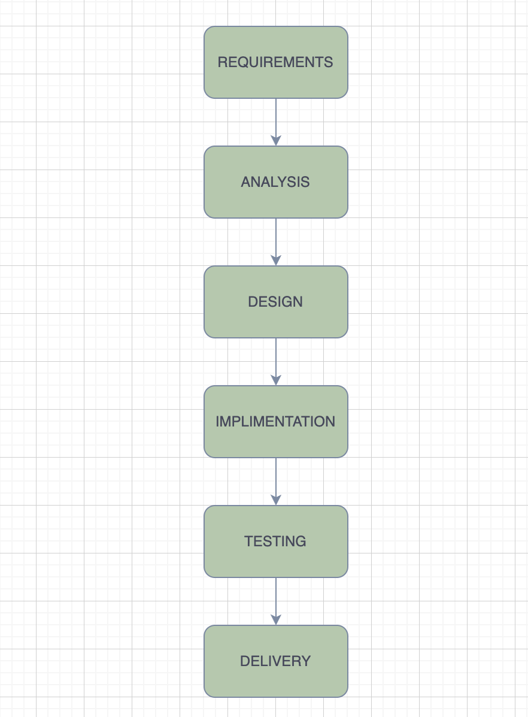

REQUIREMENT - This step is the most crucial and important step as this is the stage where we get to know the clients needs.what actually the client wants.His pre-mindset related to the service.

ANALYSIS - Here we analyse the clients requirements and make some crucial decisions on what the program needs and how the work flow shall work and giving work to the respective deparatment.

DESIGN - Here at this stage the team design the product and makes a sketch or a brief product layout and takes clients conformation on it.

IMPLIMENT- At this stage after the client approves the design and layout of the product then the team starts the real hustle by making the design come to life step by step and creats the final product.

TESTING - After the product is ready another team test the product to its limits and beyond to ensure the team has left no glitch or problems in the product and if found it is solved as soon as possible.

DELIVERY - The final step all the work ends here we deliver the product to the client and our cycle ends here.

ANS 4 - DFD stands for Data Flow Diagram, which is a graphical representation of how data flows within a system. It illustrates the inputs, outputs, processes, and data stores involved in a system or process. DFDs are commonly used in software development and systems analysis to understand and communicate the flow of data.

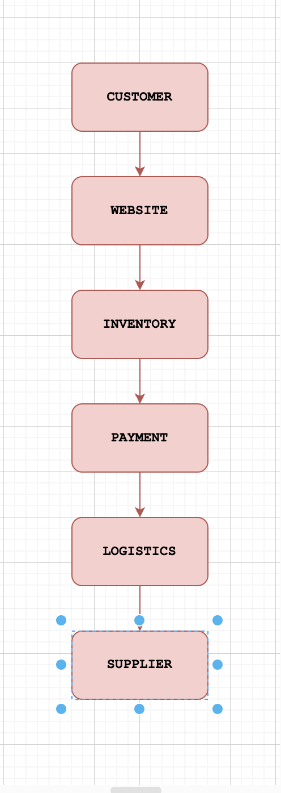

ANS 5 - A flowchart is a graphical representation of a process or algorithm that uses various symbols to depict different steps or actions. It helps visualize the flow of the process, making it easier to understand and analyze.

Here's a simple flowchart to make the addition of two numbers:

start --> Input number1

--> Input number2

--> Add number1 and number2

--> Output the result

end

In the flowchart above, "start" and "end" are terminal symbols representing the beginning and end of the flowchart, respectively. "Input number1" and "Input number2" are symbols indicating the user's input of the two numbers to be added. "Add number1 and number2" represents the mathematical operation of addition. Finally, "Output the result" signifies displaying the sum of the two numbers.

ANS 6 - A use case diagram is a visual representation that depicts the interactions between various actors (users, systems, or external entities) and a system. It illustrates the functionality of a system from the user's perspective by showing the different use cases and the actors involved in each case.

